**Name :** Grace Ranjan

**Loop Questions**

**Questions**

**Q.1) Write a program to calculate the sum of following series where n is input by user.**

**e.g 1 + 1/2 + 1/3 + 1/4 + 1/5 +…………1/n**

**Ans:**

import java.util.Scanner;

public class SeriesSum {

    public static void main(String[] args) {

        Scanner in = new Scanner(System.in);

        System.out.println("Computing sum of series: 1+ 1/2 + 1/3 + ... + 1/n");

        System.out.println("Enter the value for n: ");

        int n = in.nextInt();

        double sum=0;

        if(n == 1){

            sum = sum + 1;

        }else{

            for(int i=1; i<n; i++){

                sum = sum + (1.0/i);

            }

        }

        System.out.println("The sum is: "+ sum);

        in.close();

    }

}

**OUTPUT**

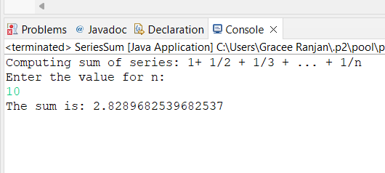

**Q.2) Find out Prime Number**

**Ans:**

import java.util.Scanner;

public class prime {

    public static void main(String[] args) {

        Scanner in = new Scanner(System.in);

        int count=0;

        System.out.println("Enter a number: ");

        int num = in.nextInt();

        if(num==1){

            System.out.println("Not a prime number!!");

        }

        else if(num==2||num==3){

            System.out.println("The number is a prime number!!");

        }

        else if(num % 2 == 0 || num % 3 == 0 ){

            System.out.println("Not a prime number!!");

        }else{

            for(int i=5;/*i<Math.sqrt(num)*/ i*i<= num ;i = i+6){

                if(num % i == 0 || num % (i+2) == 0){

                    count++;

                }

            }

            if(count==0){

                System.out.println("The number is Prime!!!");

            }else{

                System.out.println("The number is not prime!!!");

            }

        }

        in.close();

    }

}

**OUTPUT**

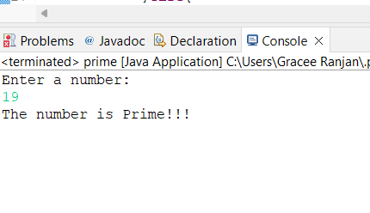

**Q.3) Reverse a Number**

**Ans:**

**import** java.util.*;

**public** **class** reverse {

**public** **static** **void** main(String args[])

{

**int** m, n, sum = 0;

Scanner s = **new** Scanner(System.***in***);

System.***out***.print("Enter the number:");

m = s.nextInt();

**while**(m > 0)

{

n = m % 10;

sum = sum * 10 + n;

m = m / 10;

}

System.***out***.println("Reverse:"+sum);

}

}

**OUTPUT**

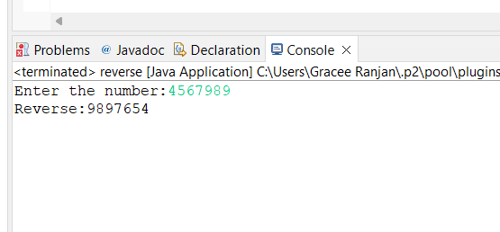

**Q.4) Find out LCM and GCD of a Number**

**Ans:**

import java.util.Scanner;

class LCM_GCD_calculator{

    public static void main(String[] args) {

        Scanner in = new Scanner(System.in);

        int i,num_1,num_2,L_num,lcm,gcd=0;

        System.out.println("Enter first number: ");

        num_1 = in.nextInt();

        System.out.println("Enter second number: ");

        num_2 = in.nextInt();

        //to find largest of two number because lcm will be equal or greater than the largest number

        L_num = num_1>num_2?num_1:num_2;

        lcm = L_num;

        while(true){

            if( (lcm % num_1 == 0) && (lcm % num_2 == 0) ){

                break;

            }

            lcm++;

        }

        System.out.println("LCM of two numbers is: "+lcm);

        //to find greatest divisor of two number

        i=1;

        while(num_1 % num_2 != 0){

            int rem = num_1 % num_2;

            num_1 = num_2;

            num_2 = rem;

        }

        System.out.println("GCD of two numbers is: "+num_2);

        in.close();

    }

}

**OUTPUT**

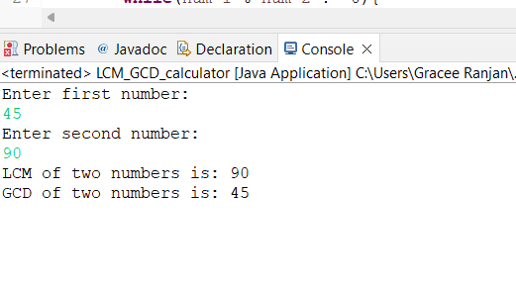

**Q.5) Implement a program to find out whether a number is divisible by the sum of its digits. Display appropriate messages.**

**e.g 2250 – Yes , 123 – NO.**

**Ans:-**

import java.util.Scanner;

public class SumDivion {

    public static void main(String[] args) {

        Scanner in = new Scanner(System.in);

        System.out.println("Enter a number: ");

        int num = in.nextInt();

        int tmp=num,sum=0;

        while(tmp>0){

            sum = sum+tmp%10;

            tmp=tmp/10;

        }

        if(num % sum == 0){

            System.out.println("Yes");

        }

        else{

            System.out.println("No");

        }

        in.close();

    }

}

**OUTPUT:-**

Q.6)  **Implement a program to find out whether a number is a seed of another number. A number X is said to be a seed of number Y if multiplying X by its every digit equates to Y. E.g.: 123 is a seed of 738 as 123*1*2*3 = 738. e.g 123, 738 – Yes ; 45,1000 – No;**

**Ans:-**

import java.util.Scanner;

public class seednum {

    public static void main(String[] args) {

        Scanner in = new Scanner(System.in);

        int num_1,num_2,S_num;

        System.out.println("Enter first number: ");

        num_1 = in.nextInt();

        System.out.println("Enter second number: ");

        num_2 = in.nextInt();

        //to find smallest of two number

        S_num = num_1<num_2?num_1:num_2;

        int tmp=S_num,product=S_num;

        while(tmp>0){

            product = product * (tmp%10);

            tmp=tmp/10;

        }

        if( (num_1<num_2) && ( product == num_2 ) ){

            System.out.println("Yes "+num_1+" is a seed of "+num_2);

        }

        else if((num_1>num_2) && ( product == num_1 ) ){

            System.out.println("Yes "+num_2+" is a seed of "+num_1);

        }else{

            System.out.println(num_1+" is not a seed of "+num_2);

        }

        in.close();

    }

}

**OUTPUT**



